Essay Cover Sheet 2021-22

|  |  |
| --- | --- |
| Course Code | DV55 |
| MSc programme (circle as applicable/add if your programme isn’t listed) | **DM** DS IDHE H&ID |
| **Candidate Number** (5 digit number from **LSE for you - NOT** from your ID card, **NOT** your Student number) | 30848 |
| Individual Strategy title | Portons la culotte (menstruelle) ! Tackling period poverty in France |
| Seminar Leader | Professor Duncan Green and Dr Tom Kirk |
| Due Date | Monday, 25th April 2022 |
| **Word Count** (*excluding* title, header, bibliography, appendices; *including* footnotes/endnotes and everything else) | 2492 |

Essays must be submitted with a header in the following format:

Course Code Page x of y 5 digit Candidate Number

**Word limit:** Exceeding the word limit will AUTOMATICALLY be penalised at the rate of 1 mark per 100 words (or part thereof).

**Late penalties:** Submitting work late *without a previously arranged extension* will AUTOMATICALLY be penalised at the rate of 5 marks per day (24 hour period, not including weekends or bank holidays) or part thereof.

**Plagiarism** **(unacknowledged borrowing or quotation)**: is an examination offence and carries heavy penalties. In submitting his/her essay the student acknowledges it as his/her own work which contains no plagiarism AND that it has not been submitted previously for any assessed unit on the course or any other degree course at the LSE or elsewhere.

I have uploaded files (either Word or .pdf) as required to **Moodle** and within the time limit.

|  |
| --- |
| X |

I have read, understood and adhered to the conditions stated above, please mark an **X** in the box to confirm this.

## Portons la culotte (menstruelle) ![1]

### Tackling period poverty in France

Period poverty is defined as the difficulty or inability for girls, women, and other menstruators to afford basic menstrual products[2] and to experience menstruation with dignity. It affects almost 2 million women in France and is still considered as an under-investigated issue, despite the French being clearly in favour of setting up measures to combat it (RE, 2021).

# Defining the problem

The government started to tackle the issue in 2015, when they decreased the “tampon tax” from 20% to 5.5%, categorizing tampons as a basic necessity (Le Monde, 2015). Since then, the government has run trials for a potential free distribution of menstrual products to women that need it, mostly in universities and prisons. In 2021, the State allocated a budget of 5 million euros to fight period poverty, which should be sustained over the years to come (Ministère des Solidarités et de la Santé, 2020).

*Figure 1 – Period poverty timeline in France*

Today, although there have been several law proposals, the government has yet to pass a law on menstrual equity[3] and considers its initiatives to be sufficient. However, as the law proposals and civil society organisations (CSOs) point out, there is a wide gap between government statements and actions, and a lot of work is still needed to end period poverty (Latil, 2020; RE, 2021). In addition, social norms are beginning to change but the taboo is still present, especially in the public and professional spheres.

# The context

* National context

The current context is in favour of action on menstrual equity, with 76% of French people considering it is a public health issue that should be solved by the government (RE, 2021). The recent presidential elections have brought up topics such as the purchasing power of French people and taxation[4], which are both relevant to period poverty (BFMTV, 2022). Putting these debates back into the context of period poverty, women lose purchasing power compared to men as they have a systematic expense to cover for. This effect is even more important for disadvantaged women.

With regards to the period poverty context, a big win was secured for feminist and period poverty advocates in January 2022, when endometriosis was finally recognised as a “long-term condition” in the National Assembly (Latil, 2022). Lessons can also be drawn from the history of the “pink tax”[5] abolishment movement and the movement to lower the “tampon tax” from 20% to 5.5%, which were both led by Georgette Sand and other feminist CSOs (Georgette Sand, 2014; Le Parisien, 2015). Both campaigns were successful thanks to support from the State Secretary for Women’s Rights and the press. Finally, the research on period poverty (both private and government-led) is consequent enough to support the case of our campaign, and the advocacy on the issue is already established.

* International context

First, the European Union will authorize member states to be more flexible their tax legislation in 2022 and urges them to exempt menstrual products from VAT (European Commission, 2018; Parlement européen, 2021). Many countries have also achieved change on menstrual equity, either by passing a law on free menstrual products like in Scotland – which could serve as an example – or by scrapping the “tampon tax” entirely like the UK or Australia (Lennon, 2019; Conseil du Statut de la Femme, Québec, 2021). Such countries could be used to put pressure on France to follow in the footsteps of other developed countries taking the lead on this issue.

# Stakeholder and power analysis

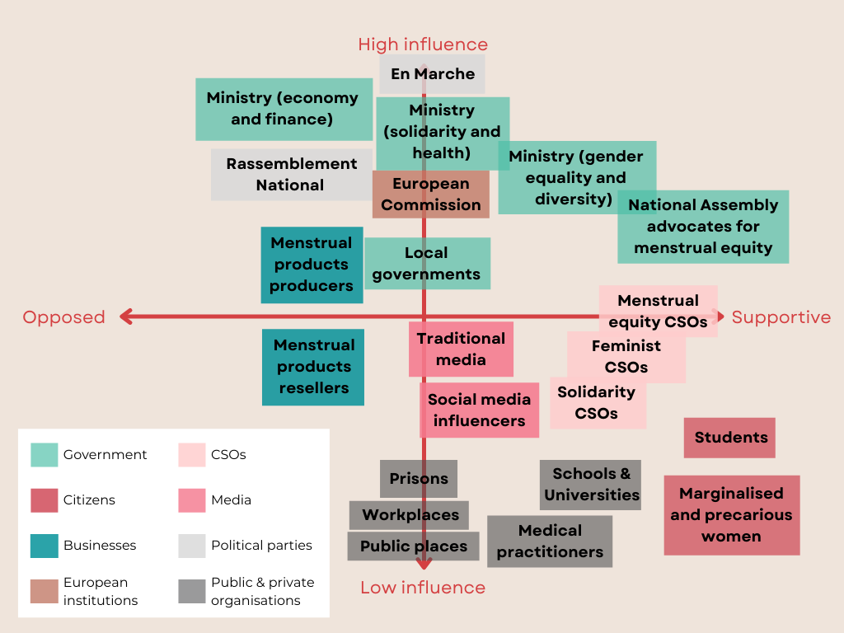

*Figure 2 – Stakeholder analysis*

* Main obstacles to campaign
* The government wishes to include period poverty into a broader mission (“Solidarity, insertion and equal opportunities”), which pushes it away from the list of priorities and drowns it into larger issues.
* The Ministry of Economy and Finance does not want to lose tax money and judges that the budget committed to the issue is large enough (5 million euros for every year to come). The current budget for this issue was voted under the finance law and is not accountable to a formal law (Ministère des Solidarités et de la Santé, 2020). The Ministry also fears that a debate on 0% taxation for menstrual products might degenerate into a debate on taxation in general, especially for basic necessities.
* Businesses selling menstrual products (producers and resellers) are opposed to regulation from the State, especially on the price of their products. Still, they have been making efforts over the past years to make their products healthier and be more transparent on their composition. Some even partner with CSOs to distribute menstrual products to those in need (Always, 2021).
* Power analysis
* The visible power here is held by the government, and more specifically the different ministries in charge of period poverty (Ministry of Solidarity and Health, Ministry of Gender, Equality and Diversity) and the National Assembly which voted against the three law propositions. They decide if a law passes or not, and if period poverty is included in their list of priorities or not.
* The invisible power rests in the persistent taboo around periods (57% of people still feel it is taboo). As CSO Règles Élémentaires points out, although 70% of people have heard about period poverty, 53% of them do not know what it is (RE, 2021). These social norms prevent a serious discussion from taking place on the issue. It also forces disadvantaged women to choose between menstrual products and other basic necessities.
* The hidden power is held by the Ministry of Economy and Finance who wishes to avoid debates on taxes and to refrain from attributing a bigger budget to the issue. It is also held by the producers and resellers of menstrual products who wish to keep some flexibility in the composition of their products and their price. The decrease of the tampon tax from 20% to 5.5% in 2015, which represented a loss of 65 million euros for the government, benefitted them more than their consumers as their prices are not controlled by the government (Latil, 2020).
* Key takeaways from the stakeholder and power analysis
* The main issue is the high influence and neutral or undecided actors (Ministry of Solidarity and Health, Ministry of Economy and Finance, local government). We will need to frame the issue in a way that appeals to their interests and highlight the positive aspects of change. We will also need to convince them that this issue is a priority, and that it cannot wait for a larger strategy to be set up (but it could be included into it later).
* We also have some low influence but highly supportive actors (Menstrual equity and feminist CSOs[6]), which could gain influence and power *with* by forming a coalition with among themselves, and with other actors such as solidarity CSOs, student associations or schools and universities. Although the advocacy of CSOs on period poverty is already establish, they lack visibility. This visibility could be provided by the coalition, as well as with the help of traditional and social media.
* There are a few influential and highly supportive actors (National Assembly advocates, Ministry for Gender, Equality and Diversity), which we should target as our champions to include in discussions with the coalition. We will be relying on them to put forward a new law proposition at the National Assembly and to carry the voice of the coalition. By collaborating with the coalition, they could show other government representatives that the campaign is supported by the public and should be prioritised.

# The strategy

* Why should we advocate for a law?
* To recognise period poverty as a public health and human rights issue, and to fight the taboo by encouraging discussions.
* To address the diversity of issues related to period poverty that cannot be tackled by a simple budget and plan (education, health, purchasing power, business regulations, taxation, awareness…). Issues which weren’t considered in government experimentations like the free provision of menstrual products, the provision in public spaces and workplaces, or the regulation and safety of products should be addressed.
* To ensure the budget committed to period poverty is sustainable and increases.
* To ensure the tax decrease of 2015 is effective by controlling the price of menstrual products, as well as their composition.
* Tactics

The campaign will use both insider and outsider tactics to make the issue of period poverty a priority and influence the government to pass a law on menstrual equity. It will strongly involve the public, as they already support the issue but do not voice their support because of the taboo. Social media will help free the discourse and reframe it.

|  |  |  |
| --- | --- | --- |
| Stakeholders | Obstacles | Tactics |
| Opposed or neutral to the movement (Ministry of Economy and Finance, Ministry of Solidarity and Health) | Period poverty is not a priority | Reframe the campaign to make period poverty not just a feminist issue, but a human rights and socio-political issue, stressing the need for human dignity and equality (UNFPA, 2021). |
| Insist on the benefits of menstrual equity and on the success of other countries, putting pressure on France to follow other developed country leaders. |
| Publish a public petition, which will be advertised by the campaign (if it collects 500 000 signatures, the petition is debated in a public hearing at the National Assembly). |
| The budget to fight period poverty is not consequent enough | Be flexible on tax measures (to not launch a major debate on 0% tax, that would not serve our cause), until the EU passes its law to allow for more flexibility. After this, the government will have the possibility to implement 0% tax on menstrual products. |
| Give options – if the government are really opposed to 0% tax, suggest that we use the money collected from taxation to fund projects on period poverty (and conduct research on the current use of this money to include in the messaging of the campaign) |
| Menstrual equity, feminist and solidarity CSOs + others | Not enough visibility for CSOs | Build a coalition with feminist, menstrual equity and solidarity CSOs, putting together all local and national initiatives to gain power. |
| Not enough visibility for the public support | Involve the traditional media into the campaign to share stories, advocate for change and report on the progress that is being made. They had already gotten involved with the “pink tax” and have already published some content on period poverty. Le Monde published a calculator for the price of periods inspired by the BBC’s calculator, and a series on period poverty across the world (Le Monde, 2019). The action needs to be big and strike all at once. |
| Launch a campaign on social media to raise awareness on period poverty, educate on menstruations and spread the word on the campaign. The social media campaign could share stories of women experiencing period poverty (e.g., students having to choose between eating and menstruating with dignity), collaborate with influencers[7] (women and men, and all types of influencers), and call for period poverty to be a priority.  #PortonsLaCulotte(Menstruelle) |
| Encourage people to advocate at their local level (schools, universities, workplaces, local government) for the provision of free menstrual products in public places. |
| Champions of the campaign (National Assembly advocates, Ministry of Gender, Equality and Diversity) | Need to show public support to make the law a priority | Collaborate and meet more regularly with the coalition of CSOs, to carry their message and show support to the campaign. |
| Need to bring in more arguments to pass the law | Meet with key politicians from countries that passed a law on menstrual equity and period poverty (for example with Monica Lennon from the Scottish Parliament) to understand how they tackled the obstacles they faced and what measures they experimented with. |

# References

1. Always. 2021. "Nonàlaprécaritémenstruelle, Le Mouvement D’ALWAYS® Pour Aider Les Jeunes Filles En Situation Précaire". https://www.always.fr/fr-fr/a-propos-de-always/non-a-la-precarite-menstruelle.
2. BFMTV. (2022). *Présidentielle 2022: Le Débat Entre Emmanuel Macron Et Marine Le Pen En Intégralité*. Video. <https://www.youtube.com/watch?v=XXL2VLmACsg>.
3. Conseil du Statut de la Femme, Québec. 2021. "Faciliter L'accès Aux Produits Menstruels - Mesures Possibles". https://csf.gouv.qc.ca/wp-content/uploads/produits-menstruels.pdf.
4. Coryton, L., & Russell, L. (2021). Paying for Our Periods: The Campaign to Tackle Period Poverty and End the Tampon Tax in the UK. Columbia Journal Of Gender And Law, 41(1), Only. <https://doi.org/10.52214/cjgl.v41i1.8820>
5. Crawford, B. J., & Waldman, E. (2021). Period Poverty in Pandemic: Harnessing Law to Achieve Menstrual Equity. Washington University Law Review, 98(5), 1569-1606. Available at SSRN: <https://ssrn.com/abstract=3692802>
6. European Commission. (2018). VAT: More flexibility on VAT rates, less red tape for small businesses. Retrieved from <https://ec.europa.eu/commission/presscorner/detail/en/IP_18_185>
7. Georgette Sand. (2014). "Quand Le Collectif Georgette Sand Tacle La Taxe Rose : Le Communiqué De Presse". <https://georgettesand.org/actualites/collectif-georgette-sand-tacle-taxe-rose-communique-presse/>.
8. Latil, Ophélie. (2022). L’Endométriose Enfin Reconnue Comme Affection De Longue Durée À L’Assemblée Nationale ! Blog. *Georgette Sand*. <http://georgettesand.com/2022/01/17/lendometriose-enfin-reconnue-comme-affection-de-longue-duree-a-lassemblee-nationale/>.
9. Latil, Ophélie. (2020). Tout Reste À Faire Pour Éradiquer La Précarité Menstruelle. Blog. *Georgette Sand*. <http://georgettesand.com/2020/02/12/tout-reste-a-faire-pour-eradiquer-la-protection-menstruelle/>.
10. Lennon, Monica. 2019. "Period Products (Free Provision) (Scotland) Bill - Policy Memorandum". *Parliament.Scot*. <https://www.parliament.scot/-/media/files/legislation/bills/current-bills/period-products-free-provision-scotland-bill/introduced/policy-memorandum-period-products-scotland-bill.pdf>.
11. Le Monde. 2019. "Combien Les Règles Coûtent-Elles Dans La Vie D’Une Femme ?". https://www.lemonde.fr/les-decodeurs/article/2019/07/02/precarite-menstruelle-combien-coutent-ses-regles-dans-la-vie-d-une-femme_5484140_4355770.html.
12. Le Monde. (2015). La baisse de la « taxe tampon » votée à l’Assemblée. Retrieved from <https://www.lemonde.fr/societe/article/2015/12/11/la-baisse-de-la-taxe-tampon-votee-a-l-assemblee_4829868_3224.html>
13. Le Parisien. (2015). "Taxe Rose : « Les Femmes Sont Plus Vigilantes »". <https://www.leparisien.fr/laparisienne/actualites/taxe-rose-les-femmes-sont-plus-vigilantes-21-12-2015-5391783.php>.
14. Ministère des Solidarités et de la Santé. (2020). Olivier Véran et Élisabeth Moreno portent à 5 millions d’euros le budget alloué par l’État pour lutter contre la précarité menstruelle en 2021. Retrieved from <https://solidarites-sante.gouv.fr/actualites/presse/communiques-de-presse/article/olivier-veran-et-elisabeth-moreno-portent-a-5-millions-d-euros-le-budget-alloue?TSPD_101_R0=087dc22938ab2000eec010d0205674cbb1a43ca12dd5b8caef5f46bde9013fa94fd0cc0ced3c36e5083d06237514300027691c82926866b649bfdfc575d186b879b761976a768e06978619431b4faf40ba8c0b6278e464b4785fb07b83eb6f88>
15. Parlement européen. (2021). Les États membres devraient garantir l’accès universel à la santé sexuelle et génésique. Retrieved from <https://www.europarl.europa.eu/news/fr/press-room/20210621IPR06637/garantir-l-acces-universel-a-la-sante-sexuelle-et-genesique>
16. Règles Élémentaires (RE). (2021). Baromètre Règles Elémentaires x Opinion Way - 1ere Edition 2021. Retrieved 19 February 2022, from <https://drive.google.com/file/d/1d9guON13dumwq_0zT2LHqGZDo5W9OXYi/view>.
17. UNFPA. 2021. "Menstruation And Human Rights - Frequently Asked Questions". *United Nations Population Fund*. https://www.unfpa.org/menstruationfaq#menstruation%20and%20human%20rights.

1. Let’s wear the (menstrual) pants!
2. Such as tampons, pads, menstrual cups or period underwear. They often resort to using substitutes like rolled up toilet paper, which are unhygienic, limit their mobility and their ability to attend school or work, and have severe consequences on their sense of dignity.
3. Defined by Jennifer Weiss-Wolf in 2015, it refers to the affordability, accessibility, and safety of menstrual products. It also includes topics like education or hygiene and sanitation, and seeks to end the stigma around periods (Crawford & Waldman, 2021).
4. More specifically, in the presidential debate, Macron pointed out that a 0% tax on some products would mostly benefit people that do not need those prices to be regulated.
5. This used to be a tax applied on products destined to women, but which existed for both men and women (e.g., razors).
6. Some examples of menstrual equity, feminist and solidarity CSOs include: Règles élémentaires, Dons Solidaires, Menstruation and You, Dans ma culotte, Co’p1 – Solidarités étudiantes, Georgette Sand, La Croix Rouge, Emmaüs… These could all be part of the coalition.
7. For example, the government recently collaborated with two youtubers, McFly and Carlito, to spread awareness on coronavirus protective measures, which went viral (FranceInfo, 2021).